

# 

### Semester Two Examination, 2018

### Question/Answer booklet

# MATHEMATICS

If required by your examination administrator, please place your student identification label in this box

**SPECIALIST**

**UNITS 1 AND 2**

## Section Two:

## Calculator-assumed

|  |  |  |  |  |  |  |  |  |  |  |
| --- | --- | --- | --- | --- | --- | --- | --- | --- | --- | --- |
| Student number: In figures |  |  |  |  |  |  |  |  |  |  |

In words

Your name

## Time allowed for this section

Reading time before commencing work: ten minutes

Working time: one hundred minutes

## Materials required/recommended for this section

***To be provided by the supervisor***

This Question/Answer booklet

Formula sheet (retained from Section One)

***To be provided by the candidate***

Standard items: pens (blue/black preferred), pencils (including coloured), sharpener,  
correction fluid/tape, eraser, ruler, highlighters

Special items: drawing instruments, templates, notes on two unfolded sheets of A4 paper, and up to three calculators approved for use in this examination

## Important note to candidates

No other items may be taken into the examination room. It is **your** responsibility to ensure that you do not have any unauthorised material. If you have any unauthorised material with you, hand it to the supervisor **before** reading any further.

## Structure of this paper

|  |  |  |  |  |  |
| --- | --- | --- | --- | --- | --- |
| Section | Number of questions available | Number of questions to be answered | Working  time (minutes) | Marks available | Percentage of examination |
| Section One:  Calculator-free | 8 | 8 | 50 | 52 | 35 |
| Section Two:  Calculator-assumed | 13 | 13 | 100 | 98 | 65 |
|  | | |  | **Total** | 100 |

|  |  |  |
| --- | --- | --- |
| Markers use only | | |
| Question | Maximum | Mark |
| 9 | 7 |  |
| 10 | 6 |  |
| 11 | 8 |  |
| 12 | 8 |  |
| 13 | 8 |  |
| 14 | 6 |  |
| 15 | 8 |  |
| 16 | 11 |  |
| 17 | 8 |  |
| 18 | 7 |  |
| 19 | 8 |  |
| 20 | 6 |  |
| 21 | 7 |  |
| S2 Total | 98 |  |
| S2 Wt (×0.6633) | 65% |  |

## Instructions to candidates

1. The rules for the conduct of examinations are detailed in the school handbook. Sitting this examination implies that you agree to abide by these rules.

2. Write your answers in this Question/Answer booklet.

3. You must be careful to confine your response to the specific question asked and to follow any instructions that are specified to a particular question.

4. Supplementary pages for the use of planning/continuing your answer to a question  
have been provided at the end of this Question/Answer booklet. If you use these pages to continue an answer, indicate at the original answer where the answer is continued, i.e. give the page number.

5. Show all your working clearly. Your working should be in sufficient detail to allow your answers to be checked readily and for marks to be awarded for reasoning. Incorrect answers given without supporting reasoning cannot be allocated any marks. For any question or part question worth more than two marks, valid working or justification is required to receive full marks. If you repeat any question, ensure that you cancel the answer you do not wish to have marked.

6. It is recommended that you do not use pencil, except in diagrams.

7. The Formula sheet is not to be handed in with your Question/Answer booklet.

Section Two: Calculator-assumed 65% (98 Marks)

This section has**thirteen (****13)** questions. Answer **all** questions. Write your answers in the spaces provided.

Working time: 100 minutes.

Question 9 (7 marks)

(a) Given that $\begin{matrix}20×19×18 \\ \overline{19×18×17×16}\end{matrix}=\begin{matrix} ^{a}P_{b} \\ \overline{ ^{c}P_{4}}\end{matrix}$, determine the values of $a, b$ and $c$. (3 marks)

(b) Determine how many integers between $1$ and $100$ inclusive are divisible by $2$, $3$ or $13$.

(4 marks)

Question 10 (6 marks)

(a) In the circle shown below, minor arc $PR$ subtends an angle of $120°$ at $O$, the centre of the circle, and the size of angle $RPQ$ is $55°$. Determine the size of angle $POQ$. (2 marks)

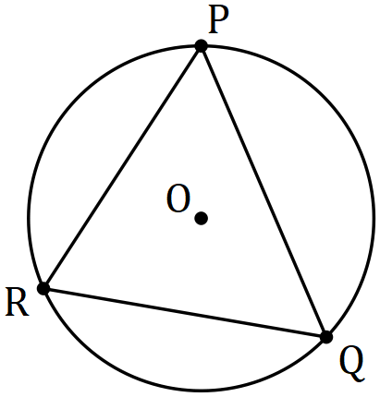

(b) In the diagram below, $AB$ is tangent to the circle with centre $O$ at $A$, secant $BD$ intersects the circle at $C$ and $D$, and the sizes of angles $AOC$ and $COD$ are $72°$ and $104°$ respectively. Determine the size of angle $ABC$. (4 marks)

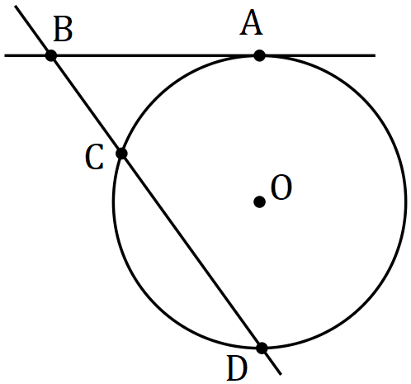

Question 11 (8 marks)

(a) Show how to express $0.\overline{23}$ as a rational number. (2 marks)

(b) Prove that the sum of any three consecutive integers is always a multiple of three.

(3 marks)

(c) Prove by contradiction that $\sqrt{7}$ is irrational. (3 marks)

Question 12 (8 marks)

Let vector $a=4i-6j$.

(a) Determine the angle between $a$ and $-7i-10j$. (1 mark)

(b) Let vector $b=14i+tj$. Determine the value of $t$ so that $a$ is

(i) parallel to $b$. (2 marks)

(ii) perpendicular to $b$. (2 marks)

(c) Determine the vector projection of $a$ on $-6i+8j$. (3 marks)

Question 13 (8 marks)

Two matrices are given by $P=\left[\begin{matrix}4 & 7 \\ -8 & 3\end{matrix}\right]$ and $Q=\left[\begin{matrix}3 & -7 \\ 8 & 4\end{matrix}\right]$.

(a) Determine $PQ$. (1 mark)

(b) Given that $Q^{-1}=kP$, determine the exact value of the constant $k$. (2 marks)

The system of equations $3a=7b+102$ and $8a+4b+34=0$ can be expressed as a matrix equation in the form $QX=R$.

(c) Determine matrices $X$ and $R$. (2 marks)

(d) Express matrix $X$ in terms of matrices $P$ and $R$. (2 marks)

(e) Solve the system of equations. (1 mark)

Question 14 (6 marks)

A segment of a circle has a perpendicular height of $h$ and width $w$.

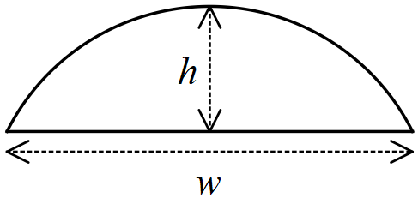

(a) Determine the radius of the arc of the segment when $h=3$ cm and $w=8$ cm. (3 marks)

(b) Use the intersecting chord theorem to derive a formula for the radius of the arc of a segment of width $w$ and height $h$, where the chords are the straight edge of the segment and the diameter of the circle. (3 marks)

Question 15 (8 marks)

Circle $C$ has equation ${\left(x-2\right)}^{2}+{\left(y+6\right)}^{2}=16$.

(a) Circle $C$ is transformed by the matrix $M=\left[\begin{matrix}0 & 1 \\ 1 & 0\end{matrix}\right]$ to circle $C'$. Describe transformation $M$ and state the equation of circle $C'$. (3 marks)

(b) Circle $C'$ is then transformed by the matrix $N=\left[\begin{matrix}3 & 0 \\ 0 & 3\end{matrix}\right]$ to circle $C''$. Describe transformation $N$ and state the equation of circle $C''$. (3 marks)

(c) Determine the single matrix $P$ that will transform circle $C''$ back to circle $C$. (2 marks)

Question 16 (11 marks)

Two forces act on a body. $F_{1}$ has a magnitude of $335$ N and acts on a bearing of $145$. $F_{2}$ has a magnitude of $295$ N and acts on a bearing of $080$.

(a) Determine

(i) the magnitude and direction of the sum of the two forces. (6 marks)

(ii) the magnitude and direction of a third force that would keep the body in equilibrium. (1 mark)

(b) The bearing $F_{2}$ acts on is changed so that the direction of $F_{1}+F_{2}$ is due east. Determine the new bearing of $F_{2}$. (4 marks)

Question 17 (8 marks)

A small body $P$ moves in a straight line. The displacement of the body from a fixed point $O$ is given by $x=a\sin\left(b\left(t+c\right)\right)+d$, where $x$ is in centimetres, $t$ is the time in seconds. The graph of $x$ against $t$ is shown below.

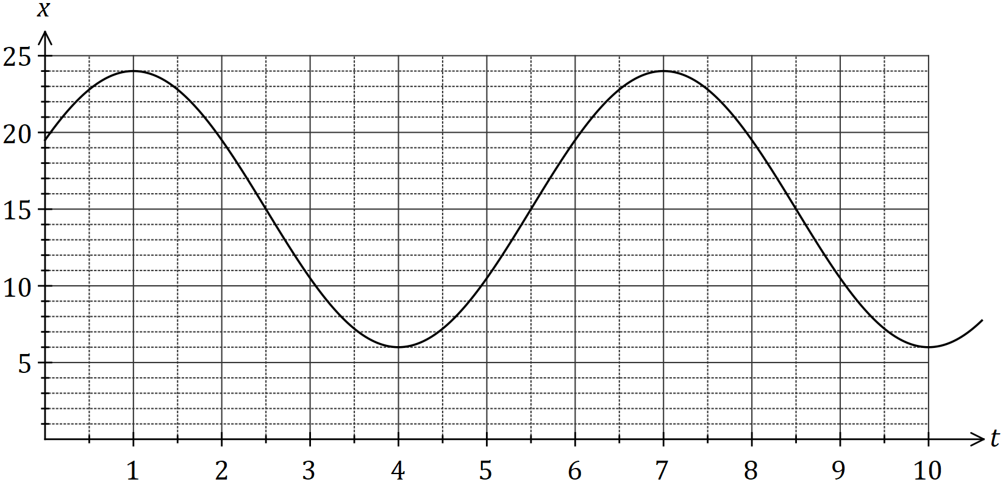

(a) Determine the values of the **positive** constants $a, b, c$ and $d$. (4 marks)

(b) Express the relationship between $x$ and $t$ as a cosine function. (2 marks)

(c) Determine the first time that $P$ is $18$ cm from $O$ after $150$ seconds, giving your answer to two decimal places. (2 marks)

Question 18 (7 marks)

Let $N=\{1, 2, 3, 4, 5, 6, 7, 8\}$.

(a) Three or four-digit codes are to be formed using integers selected from $N$, such as $287$ or $1381$.

Determine the number of codes that can be formed if

(i) there are no restrictions. (2 marks)

(ii) no integer may be used more than once in a code. (2 marks)

(b) Using the pigeon-hole principle or otherwise, prove that when five integers are selected from $N,$ at least one pair of the integers will have a sum of $9$. (3 marks)

Question 19 (8 marks)

(a) The four points $K, L, M$ and $N$ lie in that order on the circumference of a circle. Chords $KM$ and $LN$ intersect at $X$. Prove that $∆KXL\sim ∆NXM$. (4 marks)

(b) In triangle $ABC$, $P, Q$ and $R$ are the midpoints of $AB, AC$ and $BC$ respectively. If $\vec{AB}=b$ and $\vec{AC}=c$, use a vector method to prove that $PBRQ$ is a parallelogram. (4 marks)

Question 20 (6 marks)

Use mathematical induction to prove that for all positive integers $n$

$$1×5+2×6+3×7+…+n\left(n+4\right)=\frac{n}{6}\left(n+1\right)\left(2n+13\right).$$

Question 21 (7 marks)

A small drone is to fly in a straight line and at a constant altitude from $P$ to $Q$. $Q$ lies $775$ m away from $P$ on a bearing of $165°$ and a steady wind of ms-1 is blowing in the area from due east.

If the speed of the drone is set to ms-1, determine the bearing it should steer and the time that it will take to reach $Q$.

Supplementary page

Question number: _________

Supplementary page

Question number: _________

Supplementary page

Question number: _________

© 2018 WA Exam Papers. Baldivis Secondary College has a non-exclusive licence to copy and communicate this document for non-commercial, educational use within the school. No other copying, communication or use is permitted without the express written permission of WA Exam Papers. SN261-121-3.